 

**PHARMACY MANAGEMENT SYSTEM**

**A PROJECT REPORT**

***Submitted by***

**DHANASHREE J (8115U23AM015)**

***in partial fulfillment of requirements for the award of the course***

**CGB1201 - JAVA PROGRAMMING**

***In***

**DEPARTMENT OF**

**COMPUTER SCIENCE AND ENGINEERING**

(ARTIFICAL INTELLIGENECE AND MACHINE LEARNING)



**K. RAMAKRISHNAN COLLEGE OF ENGINEERING**

(An Autonomous Institution, affiliated to Anna University Chennai and Approved by AICTE, New Delhi)

**SAMAYAPURAM – 621 112**

**DECEMBER - 2024**

**K. RAMAKRISHNAN COLLEGE OF ENGINEERING**

**(Autonomous Institution affiliated to Anna University, Chennai)**

**TRICHY-621 112**

**BONAFIDE CERTIFICATE**

Certified that this project report on **“PHARMACY MANAGEMENT SYSTEM”** is the bonafide work of **DHANASHREE J (8115U23AM015)** who carried out the project work during the academic year 2024 - 2025 under my supervision.

|  |  |
| --- | --- |
| **SIGNATURE** | **SIGNATURE** |
| **MR.B.KIRAN BALA. B.Tech., M.E., M.B.A., Ph.D., M.I.S.T.E., U.A.C.E.E., IAENG** | **Mrs.P. GEETHA M.E.,** |
| **HEAD OF THE DEPARTMENT** | **ASSISTANT PROFESSOR** |
| Department Of Artificial Intelligence And Machine Learning | Department of Artificial Intelligence And Data science |
| 1. Ramakrishnan College of Engineering (Autonomous)   Samayapuram–621112 | K.Ramakrishnan College of Engineering  (Autonomous)  Samayapuram–621112 |

Submitted for the End Semester Examination held on …………….

**INTERNAL EXAMINER EXTERNAL EXAMINER**

**DECLARATION**

I declare that the project report on **“PHARMACY MANAGEMENT SYSTEM”** is the result of original work done by us and best of our knowledge, similar work has not been submitted to **“ANNA UNIVERSITY CHENNAI”** for the requirement of

Degree of **BACHELOR OF ENGINEERING**. This project report is submitted on

the partial fulfilment of the requirement of the completion of the course **CGB1201 -**

**JAVA PROGRAMMING.**

.

**Signature**

DHANASHREE J

Place: Samayapuram

Date:

**ACKNOWLEDGEMENT**

It is with great pride that I express our gratitude and in-debt to our institution

“**K.Ramakrishnan College of Engineering (Autonomous)**”, for providing us with

the opportunity to do this project.

I glad to credit honourable chairman **Dr. K. RAMAKRISHNAN**, **B.E.,** for

having provided for the facilities during the course of our study in college.

I would like to express our sincere thanks to our beloved Executive Director

**Dr. S. KUPPUSAMY, MBA, Ph.D.,** for forwarding to our project and offering

adequate duration in completing our project.

I would like to thank **Dr. D. SRINIVASAN, B.E, M.E., Ph.D.,** Principal, who

gave opportunity to frame the project the full satisfaction.

I whole heartily thanks to **Dr. B. KIRAN BALA, B.Tech., M.E., M.B.A.,**

**Ph.D., M.I.S.T.E., U.A.C.E.E., IAENG** ,Head of the department, **Artificial**

**Intelligence and Machine Learning** for providing her encourage pursuing this

project.

I express our deep expression and sincere gratitude to our project supervisor

**Mr.P.GEETHA M.E,** Department of **Artificial Intelligence and data Science,** for his

incalculable suggestions, creativity, assistance and patience which motivated us to

carry out this project.

I render our sincere thanks to Course Coordinator and other staff members for

providing valuable information during the course.

I wish to express our special thanks to the officials and Lab Technicians of our

departments who rendered their help during the period of the work progress

## INSTITUTE VISION AND MISSION

**VISION OF THE INSTITUTE:**

To achieve a prominent position among the top technical institutions.

**MISSION OF THE INSTIITUTE:**

**M1:** To best owstandard technical education parexcellence through state of the art infrastructure, competent faculty and high ethical standards.

**M2:** To nurture research and entrepreneurial skills among students in cutting edge technologies.

**M3:** To provide education for developing high-quality professionals to transform the society.

## DEPARTMENT VISION AND MISSION

**DEPARTMENT OF CSE(ARTIFICIAL INTELLIGENCE AND MACHINELEARNING)**

**Vision of the Department**

To become a renowned hub for Artificial Intelligence and Machine Learning

Technologies to produce highly talented globally recognizable technocrats to meet

Industrial needs and societal expectations.

**Mission of the Department**

**M1**: To impart advanced education in Artificial Intelligence and Machine Learning,

Built upon a foundation in Computer Science and Engineering.

**M2**: To foster Experiential learning equips students with engineering skills to

Tackle real-world problems.

**M3**: To promote collaborative innovation in Artificial Intelligence, machine

Learning, and related research and development with industries.

**M4**: To provide an enjoyable environment for pursuing excellence while upholding

Strong personal and professional values and ethics.

**Programme Educational Objectives (PEOs):**

Graduates will be able to:

**PEO1**: Excel in technical abilities to build intelligent systems in the fields of

Artificial Intelligence and Machine Learning in order to find new opportunities.

**PEO2**: Embrace new technology to solve real-world problems, whether alone or

As a team, while prioritizing ethics and societal benefits.

**PEO3**: Accept lifelong learning to expand future opportunities in research and

Product development.

**Programme Specific Outcomes (PSOs):**

**PSO1**: Ability to create and use Artificial Intelligence and Machine Learning

Algorithms, including supervised and unsupervised learning, reinforcement

Learning, and deep learning models.

**PSO2**: Ability to collect, pre-process, and analyze large datasets, including data

Cleaning, feature engineering, and data visualization..

**PROGRAM OUTCOMES(POs)**

Engineering students will be able to:

**1. Engineering knowledge:** Apply the knowledge of mathematics, science, engineering fundamentals, and an engineering specialization to the solution of complex engineering problems.

**2.Problemanalysis:**Identify,formulate,reviewresearchliterature,andanalyzecomplex engineering problems reaching substantiated conclusions using first principles of mathematics, natural sciences, and engineering sciences

**3.Design/development of solutions:** Design solutions for complex engineering problems and design system components or processes that meet the specified needs with appropriate consideration for the public health and safety, and the cultural, societal, and environmental considerations

**4.Conduct investigations of complex problems:** Use research-based knowledge and research methods including design of experiments, analysis and interpretation of data, and synthesis of the information to provide valid conclusions

**5.Modern tool usage:** Create, select, and apply appropriate techniques, resources, and modern engineering and IT tools including prediction and modeling to complex engineering activities with an understanding of the limitations

**6.The engineer and society:** Apply reasoning informed by the contextual knowledge to assess societal, health, safety, legal and cultural issues and the consequent responsibilities relevant to the professional engineering practice

**7.Environment and sustainability:** Understand the impact of the professional engineering solutions in societal and environmental contexts,

and demonstrate the knowledge of, and need for sustainable development

**8.Ethics:** Apply ethical principles and commit to professional ethics and responsibilities and norms of the engineering practice.

**9.Individual and team work:** Function effectively as an individual, and as a member or leader in diverse teams, and in multidisciplinary settings.

**10.Communication:** Communicate effectivelyon complex engineering activities with the engineering community and with society at large, such as, being able to comprehend and write effective reports and design documentation, make effective presentations, and give and receive clear instructions.

**11.Project management and finance:** Demonstrate knowledge and understanding of the engineering and management principles and apply these to one’s own work, as a member and leader in a team, to manage projects and in multidisciplinary environments.

**12.Life-long learning:** Recognize the need for, and have the preparation and ability to engage in independent and life-long learning in the broadest context of technological change.

# 

# ABSTRACT

A Pharmacy Management System (PMS) is a software application designed to streamline and

automate the various operations of a pharmacy. It provides a centralized platform for managing

inventory, tracking drug prescriptions, sales, billing, and customer information. The system helps

pharmacists maintain an accurate stock of medications, manage prescription refills, and monitor

expiry dates to prevent the sale of expired products. Additionally, it ensures compliance with legal

regulations by managing controlled substances and maintaining appropriate records.

The system allows pharmacists to easily manage daily transactions, generate sales reports, and

analyze customer purchasing patterns. By integrating features such as barcode scanning and digital

inventory management, it reduces human error and increases operational efficiency. The PMS also

includes a user-friendly interface for both pharmacy staff and customers, enhancing the customer

experience through faster service and accurate information.

Overall, a Pharmacy Management System not only improves the accuracy and efficiency of

pharmacy operations but also enhances customer satisfaction and ensures that the pharmacy adheres

to industry standards and regulations.

ABSTRACT WITH POs AND PSOs MAPPING

|  |  |  |
| --- | --- | --- |
| **ABSTRACT** | **POs MAPPED** | **PSOs MAPPED** |
| The Pharmacy management system is a comprehensive solution designed to streamline the operations of pharmacies by integrating inventory management, billing, and point-of-sale (POS) functionalities. It leverages modern technology to ensure accurate medicine stock tracking, expiration alerts, automated billing, and compliance with regulatory standards. The system includes a user-friendly interface and secure database integration to improve operational efficiency, reduce errors, and enhance customer satisfaction. | **PO1,PO5,**  **PO8,PO11** | **PSO1,PSO2** |

Note: 1- Low, 2-Medium, 3- High

vii

# TABLE OF CONTENTS

|  |  |  |
| --- | --- | --- |
| **CHAPTER** No. | TITLE | **PAGE** No. |
|  | ABSTRACT |  |
| 1 | INTRODUCTION |  |
|  | 1.1 Objective |  |
|  | 1.2 Overview |  |
|  | 1.3 Java Programming concepts |  |
| 2 | PROJECT METHODOLOGY |  |
|  | 2.1 Proposed Work |  |
|  | 2.2 Block Diagram |  |
| 3 | MODULE DESCRIPTION |  |
|  | 3.1 |  |
|  | 3.2 |  |
|  | 3.3 |  |
|  | 3.4 |  |
|  | 3.5 |  |
| 4 | RESULTS AND DISCUSSION |  |
| 5 | CONCLUSION |  |
|  | REFERENCES |  |
|  | APPENDIX |  |

# viii

# CHAPTER 1

# INTRODUCTION

# Objective

**Efficient Inventory Management:**  
To maintain an accurate and up-to-date inventory of pharmaceutical products, including tracking stock levels, monitoring expiry dates, and generating alerts for reordering supplies.

**Prescription Management:**  
To enable the seamless processing and management of customer prescriptions, ensuring that medications are dispensed correctly and in compliance with medical guidelines.

**Billing and Sales Management:**  
To automate the billing process, generate invoices, and track sales transactions efficiently, reducing errors and enhancing the speed of service.

**Customer Relationship Management (CRM):**  
To store and manage customer data, track their medication history, preferences, and purchase patterns, thereby improving customer satisfaction and fostering loyalty.

**Regulatory Compliance and Reporting:**  
To ensure adherence to regulatory requirements, including maintaining records for controlled substances, generating sales reports, and providing necessary documentation for audits and inspections.

**Data Security and Privacy:**  
To protect sensitive customer information through secure login systems, data

encryption, and access control, ensuring that personal and medical details remain confidential.

**Barcode Integration and Drug Identification:**  
To use barcode scanning for efficient drug dispensing and stock management, reducing the risk of human errors and ensuring accurate tracking of medications.

**Real-time Monitoring and Alerts:**  
To provide real-time data on stock levels, expiry dates, and prescription status, with automated alerts to prevent stockouts or the sale of expired medications.

**Cost Optimization:**  
To streamline operations, reduce overhead costs, and improve procurement practices by providing insights into inventory turnover and pricing trends.

**User-friendly Interface:**  
To develop an intuitive and easy-to-use interface for pharmacy staff, enabling quick training and seamless interaction with the system

The objective of the Pharmacy Management System is to enhance operational efficiency, improve customer service, ensure compliance, and streamline pharmacy processes through automation and effective data management.

# Overview

A Pharmacy Management System (PMS) is a comprehensive software solution designed to automate and streamline the operations of a pharmacy. It integrates various functions such as inventory management, prescription processing, sales and

billing, customer management, and regulatory compliance into a single platform. The system aims to improve the overall efficiency, accuracy, and effectiveness of pharmacy operations, reducing manual work, minimizing errors, and ensuring better service delivery.

The core functions of a PMS include **inventory tracking**, where the system monitors the stock of medications, keeping track of quantities, expiry dates, and reorder levels. **Prescription management** ensures that prescriptions are correctly processed, recorded, and dispensed in accordance with medical guidelines. The system also provides **billing and sales functionality**, enabling pharmacies to generate invoices, process payments, and maintain sales records easily.

A significant feature of the PMS is **customer management**, which helps track customer data, medication history, and preferences, enhancing personalized service and customer loyalty.

Additionally, the system provides **reporting and analytics tools**, offering insights into sales trends, stock levels, and financial performance, which aids in decision-making and operational planning.

Pharmacy Management Systems are also designed to ensure **regulatory compliance**, helping pharmacies adhere to legal requirements, such as managing controlled substances and generating reports for audits. The system also often includes **data security measures** to protect sensitive patient and transaction information, ensuring confidentiality and compliance with privacy regulations.

Ultimately, the Pharmacy Management System improves operational efficiency, reduces human errors, ensures customer satisfaction, and helps pharmacies meet

industry standards and regulations, making it a vital tool for modern pharmacy operations.

* 1. **Java Programming Concepts**

****1. Object-Oriented Programming (OOP)****

OOP principles are extensively used in the design of this system:

#### ****a. Classes and Objects****

****Classes****:

Medicine, Sale, and PharmacyManagementSystem are custom classes.

They encapsulate related attributes and behaviors, representing real-world entities.

****Objects****:

Instances of Medicine represent each medicine in the inventory.

Instances of Sale represent sales transactions.

#### ****b. Encapsulation****

****Definition****: Bundling data (fields) and methods that operate on the data within a single unit (class).

****Example****:

Class Medicine encapsulates attributes like name, price, quantity, and expiryDate with its constructor for initialization.

These attributes are private and accessed only through the object.

#### ****c. Abstraction****

Complex operations like processing prescriptions or updating stock are abstracted into methods (processPrescription, updateStock) in the PharmacyManagementSystem class.

#### ****d. Polymorphism****

****Definition****: The ability to take many forms.

****Example****:

Method overloading can be added for methods like updateStock, allowing updates with different parameters (e.g., update by quantity or price).

#### ****e. Association****

Objects of the Medicine class are associated with the PharmacyManagementSystem class via the HashMap.d with the PharmacyManagementSystem class via the HashMap.

### ****2.Collections Framework****

### The program uses Java's ****Collections Framework**** to handle dynamic data efficiently:

#### ****a.****HashMap

Used for the inventory system, where medicines are stored and retrieved efficiently using their names as keys.

#### ****b.****ArrayList

Used to store a list of Sale objects, providing dynamic resizing and easy iteration over sales data.

### ****3.Input and Output (I/O)****

****Concept****: User interaction is implemented using standard input/output streams.

****Example****:

Scanner is used to capture user input (medicine details, customer details, etc.).

System.out.println and formatted output (printf) are used to display inventory and sales reports.

**CHAPTER 2**

**PROJECT METHODOLOGY**

**2.1Proposed Work**

1. User Management

Admin Panel: Admin can create and manage users such as pharmacists, cashiers, and stock managers.

Roles & Permissions: Admin assigns specific roles to users with access control and permissions for each functionality.

2. Inventory Management

Stock Management: Track and manage the quantity of medicines, expiration dates, and reorder levels.

Purchase and Suppliers: Add and track medicine suppliers, purchase orders, and prices.

Expiry Management: Alerts for medicines nearing expiration.

Stock Alerts: Notifications when stock levels fall below a set threshold.

3. Prescription Management

Prescription Entry: Pharmacists can input prescriptions into the system, linking them to patient records.

Drug Interaction Alerts: Automatically checks for potential interactions between drugs prescribed.

Prescription History: Maintains a detailed history of prescriptions for each patient.

4. Sales and Billing

Point of Sale (POS): Easy-to-use interface for generating sales invoices, applying discounts, and processing payments.

Payment Integration: Supports multiple payment methods, including cash, card, and online transactions.

Receipt Management: Generate and print receipts, with options for email or SMS receipt sending.

Return & Refund: Handles product returns and refund processes.

5. Customer Management

Customer Profiles: Maintain detailed customer records, including contact info, prescription history, and purchase history.

Loyalty Program: Implement a reward system based on frequent purchases or points for customers.

Alerts & Notifications: Send reminders for prescription refills or promotions.

6. Reporting & Analytics

Sales Reports: Generate daily, weekly, or monthly sales reports.

Inventory Reports: Track stock levels, fast-moving items, and inventory costs.

Financial Reports: Generate profit and loss reports, balance sheets, and expense reports.

Customer Reports: Track purchasing trends and customer demographics.

7. Drug Database & Information

Drug Information: Integrated with a comprehensive drug database providing details about dosage, side effects, interactions, etc.

Search and Filter: Allow users to search for drugs based on name, category, or purpose.

Barcode Scanning: Ability to scan barcodes to identify and add drugs to the system.

8. Security and Backup

Data Security: Ensure sensitive information (e.g., patient details) is encrypted and protected from unauthorized access.

Backup: Automatic or scheduled backups of all data to avoid loss.

**2.2 Block Diagram**

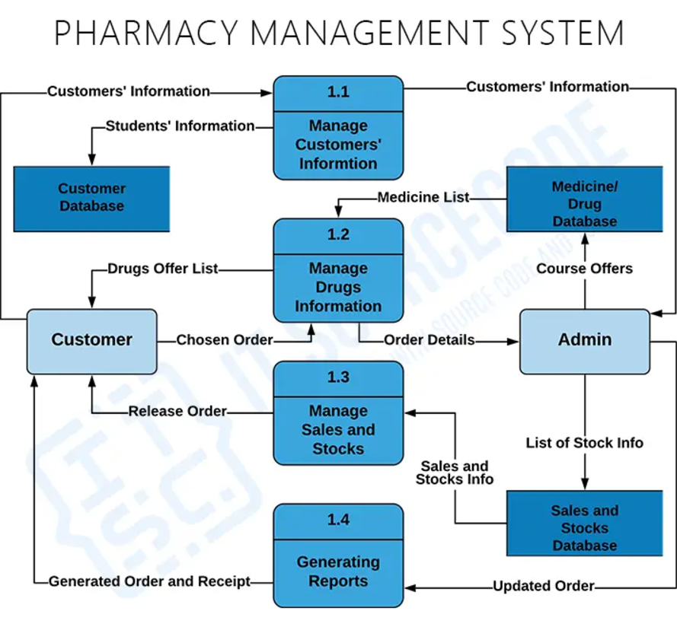

**CHAPTER 3**

**MODULE DESCRIPTION**

3.1 **java.util.Scanner :**

****Purpose****: Used for user input.

****Functionality****:

Captures inputs from the keyboard, such as medicine details or user menu selections.

****Key Methods Used****:

nextLine() - Reads a line of text.

nextInt() - Reads an integer.

nextDouble() - Reads a double (decimal number

3.2 **java.util.HashMap :**

****Purpose****: Used to store and manage the inventory of medicines.

****Functionality****:

Maps medicine names (keys) to Medicine objects (values) for efficient retrieval.

****Key Methods Used****:

put(key, value) - Adds a new medicine to the inventory.

containsKey(key) - Checks if a medicine exists in the inventory.

get(key) - Retrieves a Medicine object by its name.

values() - Iterates over all stored Medicine objects

#### 3.3 **java.util.ArrayList**

****Purpose****: Used to store a list of sales transactions.

****Functionality****:

Maintains an ordered collection of Sale objects.

Efficient for adding and iterating over sales data.

****Key Methods Used****:

add(value) - Adds a new sale to the list.

Enhanced for loop - Iterates over all sales records

## 

**CHAPTER 4**

**RESULTS AND DISCUSSION**

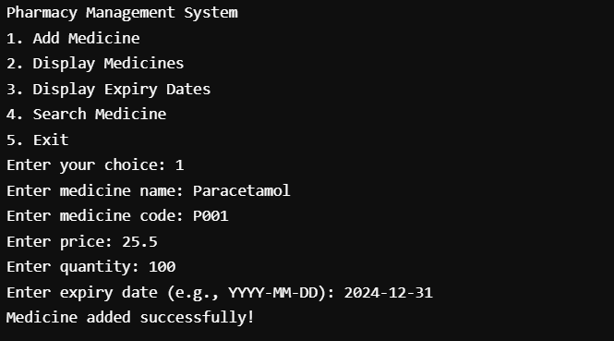

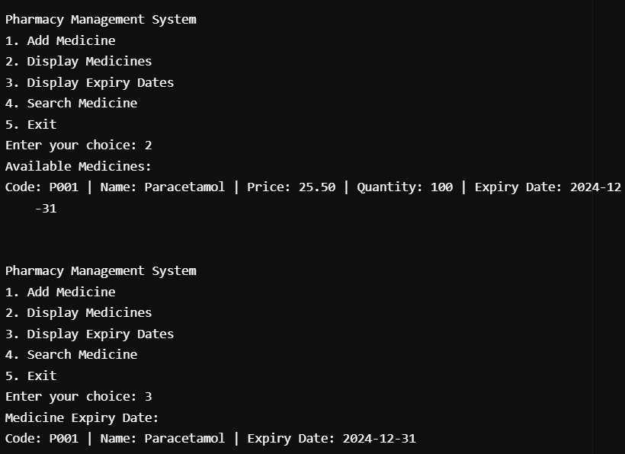

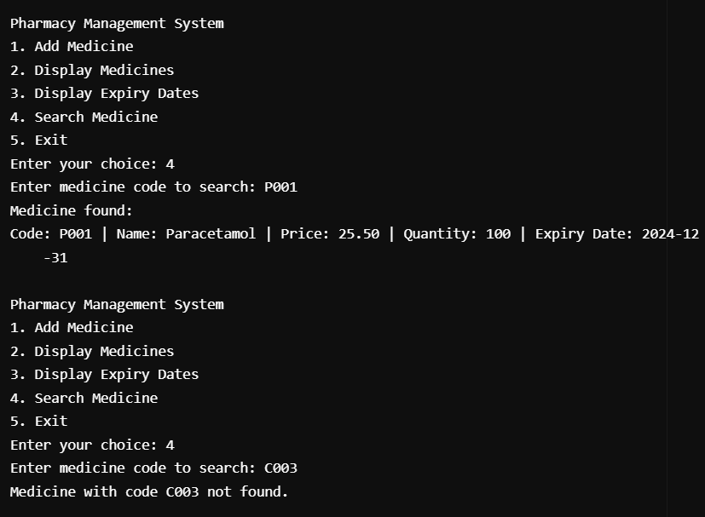

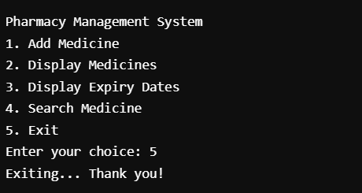

**CHAPTER 5**

**CONCLUSION**

### 

The **Pharmacy Management System** is an innovative tool designed to optimize pharmacy operations, making them efficient, accurate, and organized. By automating tasks such as inventory management, prescription handling, and sales reporting, the system reduces manual workload, minimizes errors, and saves time. It allows real-time tracking of stock levels, ensuring medicines are well-maintained and shortages or overstocking are avoided. Prescription processing is streamlined, enabling faster service delivery and boosting customer satisfaction. The system also generates detailed sales and inventory reports, providing valuable insights for better decision-making and business growth.

Built with scalability and flexibility, the system can evolve to meet future requirements. Features like database integration, multi-user support, and analytics can be incorporated, making it suitable for larger operations. It offers an intuitive interface, ensuring ease of use for pharmacy staff without extensive training. By automating calculations, expiry tracking, and data validation, it reduces operational errors and ensures regulatory compliance.

With its modular design, the Pharmacy Management System can adapt to various environments, offering opportunities for future expansion, such as cloud integration and mobile applications. Overall, it improves operational efficiency, customer experience, and profitability, making it an essential step toward modernizing pharmacy management and enhancing healthcare delivery.

**APPENDIX**

**(Coding)**

import java.util.ArrayList; // Importing ArrayList for dynamic storage

import java.util.Scanner; // Importing Scanner for user input

// Class representing a Medicine entity

class Medicine {

String name; // Name of the medicine

String code; // Unique code for the medicine

double price; // Price of the medicine

int quantity; // Available quantity of the medicine

String expiryDate; // Expiry date of the medicine

// Constructor to initialize Medicine details

public Medicine(String name, String code, double price, int quantity, String expiryDate) {

this.name = name; // Set the medicine name

this.code = code; // Set the unique code

this.price = price; // Set the price

this.quantity = quantity; // Set the quantity

this.expiryDate = expiryDate; // Set the expiry date

}

// Method to display complete medicine information

public void displayInfo() {

System.out.printf(

"Code: %s | Name: %s | Price: %.2f | Quantity: %d | Expiry Date: %s\n",

code, name, price, quantity, expiryDate

);

}

// Method to display only the expiry date

public void displayExpiryDate() {

System.out.printf(

"Code: %s | Name: %s | Expiry Date: %s\n",

code, name, expiryDate

);

}

}

// Main class for the Pharmacy Management System

public class Main {

// List to store medicines

private ArrayList<Medicine> medicines = new ArrayList<>();

// Method to add a new medicine to the inventory

public void addMedicine(String name, String code, double price, int quantity, String expiryDate) {

// Create a new Medicine object

Medicine newMedicine = new Medicine(name, code, price, quantity, expiryDate);

// Add the medicine to the list

medicines.add(newMedicine);

// Confirm successful addition

System.out.println("Medicine added successfully!");

}

// Method to display all medicines in the inventory

public void displayMedicines() {

if (medicines.isEmpty()) { // Check if the list is empty

System.out.println("No medicines available."); // Inform the user

} else {

System.out.println("Available Medicines:");

for (Medicine med : medicines) { // Loop through each medicine

med.displayInfo(); // Display information

}

}

}

// Method to display only expiry dates of medicines

public void displayExpiryDates() {

if (medicines.isEmpty()) { // Check if the list is empty

System.out.println("No medicines available."); // Inform the user

} else {

System.out.println("Medicine Expiry Dates:");

for (Medicine med : medicines) { // Loop through each medicine

med.displayExpiryDate(); // Display expiry date

}

}

}

// Method to search for a medicine by its code

public void searchMedicine(String code) {

for (Medicine med : medicines) { // Iterate through the list

if (med.code.equalsIgnoreCase(code)) { // Check for a match

System.out.println("Medicine found:"); // Match found

med.displayInfo(); // Display details

return; // Exit method

}

}

// If no match is found

System.out.println("Medicine with code " + code + " not found.");

}

// Main method to run the Pharmacy Management System

public static void main(String[] args) {

// Create an instance of the Pharmacy Management System

Main pharmacySystem = new Main();

// Create a Scanner object for user input

Scanner scanner = new Scanner(System.in);

// Loop to display the menu and process user input

while (true) {

// Display menu options

System.out.println("\nPharmacy Management System");

System.out.println("1. Add Medicine");

System.out.println("2. Display Medicines");

System.out.println("3. Display Expiry Dates");

System.out.println("4. Search Medicine");

System.out.println("5. Exit");

// Prompt the user to make a choice

System.out.print("Enter your choice: ");

int choice = scanner.nextInt(); // Read the user's choice

scanner.nextLine(); // Consume the leftover newline

// Process user input

switch (choice) {

case 1:

// Add a new medicine

System.out.print("Enter medicine name: ");

String name = scanner.nextLine(); // Read medicine name

System.out.print("Enter medicine code: ");

String code = scanner.nextLine(); // Read medicine code

System.out.print("Enter price: ");

double price = scanner.nextDouble(); // Read price

System.out.print("Enter quantity: ");

int quantity = scanner.nextInt(); // Read quantity

scanner.nextLine(); // Consume the leftover newline

System.out.print("Enter expiry date (e.g., YYYY-MM-DD): ");

String expiryDate = scanner.nextLine(); // Read expiry date

// Add the medicine to the inventory

pharmacySystem.addMedicine(name, code, price, quantity, expiryDate);

break;

case 2:

// Display all medicines

pharmacySystem.displayMedicines();

break;

case 3:

// Display expiry dates of all medicines

pharmacySystem.displayExpiryDates();

break;

case 4:

// Search for a medicine

System.out.print("Enter medicine code to search: ");

String searchCode = scanner.nextLine(); // Read the code to search

// Perform the search

pharmacySystem.searchMedicine(searchCode);

break;

case 5:

// Exit the program

System.out.println("Exiting... Thank you!");

scanner.close(); // Close the Scanner

return; // Exit the program

default:

// Handle invalid choice

System.out.println("Invalid choice! Please try again.");

}

}

}

}

**REFERENCES :**

"Development of Pharmacy Management System with RFID Integration"

Explores RFID technology for efficient inventory management and expiry tracking in pharmacy systems.

Published in International Journal of Advanced Computer Science and Applications.

"Design and Implementation of a Cloud-Based Pharmacy Management System"

Discusses the use of cloud computing for pharmacy software, enabling remote access and data synchronization.

Published in Journal of Healthcare Engineering.

"Role of Information Technology in Enhancing Pharmacy Workflow"

Reviews the impact of IT systems on operational efficiency in retail pharmacies.

Published in Journal of Pharmaceutical Sciences.

Websites & Online Resources:

PubMed (https://pubmed.ncbi.nlm.nih.gov)

Search for scholarly articles and case studies on pharmacy systems and automation.

ScienceDirect (https://www.sciencedirect.com)

Offers papers on healthcare informatics and pharmacy technology.

SpringerLink (https://link.springer.com)

Contains publications on pharmacy management systems and healthcare software.

IEEE Xplore (https://ieeexplore.ieee.org)

Includes research on pharmacy software development and related technologies.

Case Studies:

Case Study: Implementation of a POS-Based Pharmacy System

Describes the practical benefits of integrating a Point-of-Sale system with pharmacy operations.